EVERBUILD MAMMOTH HEAVY DUTY WEATHERPOOF TAPE

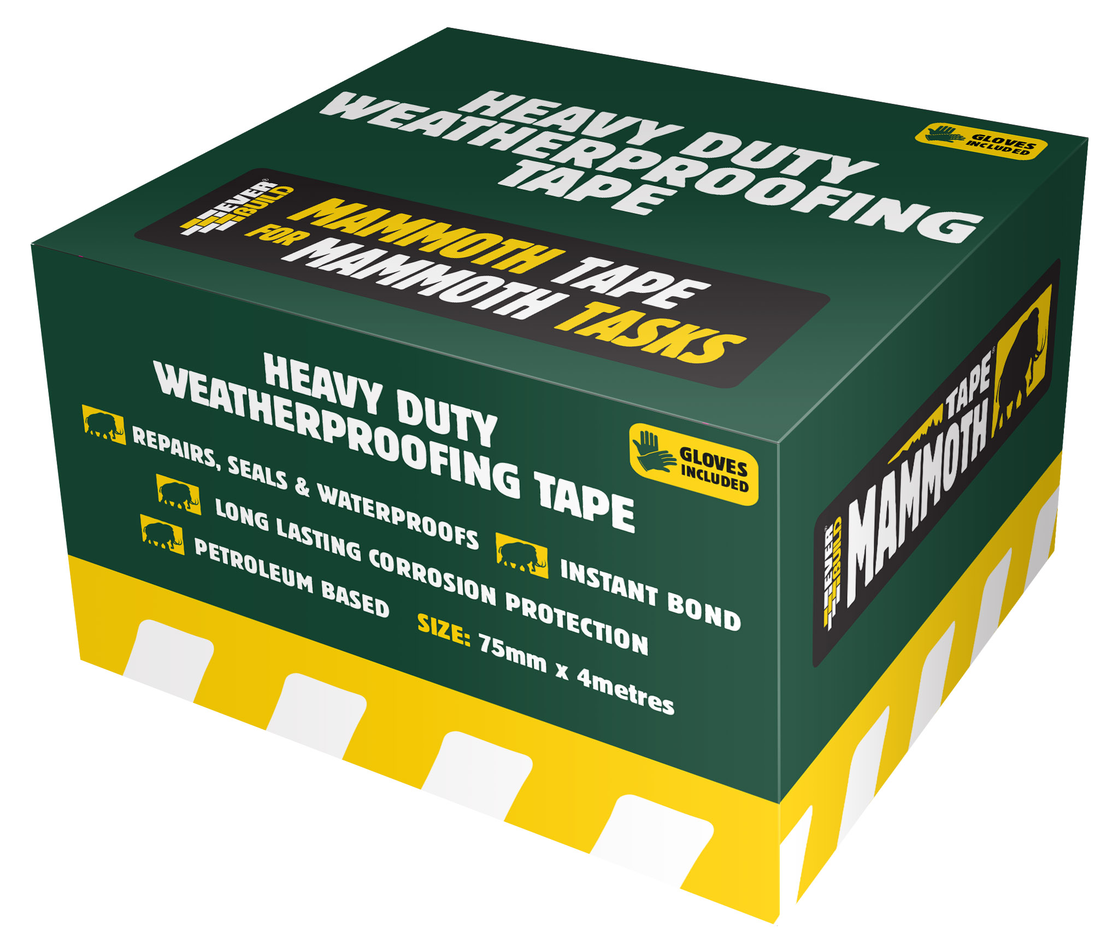
Colour | Product Code | Pack Size | Box Qty
Beige | 2WEATHER50 | 50mm x 4Mtr | 12
Beige | 2WEATHER75 | 75mm x 4Mtr | 10

Product Description
EVERBUILD MAMMOTH HEAVY DUTY WEATHERPROOF TAPE is a versatile, cold applied petrolatum based corrosion control, waterproofing and sealing tape. Supplied in easy use rolls which are manufactured from a polyester fabric carrier, fully impregnated with a homogeneous blend of petrolatum and inert mineral fillers. The tapes are resistant to mineral acids, alkalis, and salts and bacterial attack and remain flexible and highly impermeable to water vapour. Conforms to BGC/PS/CW2

Benefits
- Easy to apply with minimum surface preparation
- Gives long lasting protection
- Easy to repair or replace after inspection
- Immediate bond to substrate
- Conforms to any surface
- Cold applied with no curing time
- Resistant to dilute Mineral Acids, Alkalis and Salts
- Non Cracking and Non Absorbent to Moisture
- Overpaintable

Limitations
- Do not use on surfaces that bleed oils or plasticiser.
- It is the users responsibility to determine suitability for use. If in doubt contact technical services for advice.

Application
Surface Preparation -The surface should be as dry and clean as possible. Use a wire brush to remove all loose matter, dirt, rust etc. before application.

Apply tape directly from roll spirally around the substrate with a minimum 25mm overlap, taking care to prevent air pockets. Finish smooth out and press down well over the tape surface to ensure overlap seal.
Specific Data

Tape material | Polyester fabric
Thickness | 1.15mm
Coating weight | 1.4-1.5kg/M²
Service Temperature | -5°C to +55°C
Tape strength | 100N/25mm

Storage
Store in cool dry conditions between +5 and 25⁰C. Do not store above +35ºC or in direct sunlight.

Safe in normal use however as a precaution keep outer packaging away from children.

Shelf Life
Shelf life 36 months from date of manufacture.

The technical data contained herein is based on our present knowledge and experience and we cannot be held liable for any errors, inaccuracies, omissions or editorial failings that result from technological changes or research between the date of issue of this document and the date the product is acquired. Before using the product, the user should carry out any necessary tests in order to ensure that the product is suitable for the intended application. Moreover, all users should contact the seller or the manufacturer of the product for additional technical information concerning its use if they think that the information in their possession needs to be clarified in any way, whether for normal use or a specific application of our product. Our guarantee applies within the context of the statutory regulations and provisions in force, current professional standards and in accordance with the stipulations set out in our general sales conditions. The information detailed in the present technical data sheet is given by way of indication and is not exhaustive. The same applies to any information provided verbally by telephone to any prospective or existing customer.

